

**WireFrame Documentation**

**Airbnb Data Analysis**

Author :

Hemant Sharma, Anurag Gupta

**HomePage :**

As per the problem statement, we have divided analysis dashboard into seven visualizations:

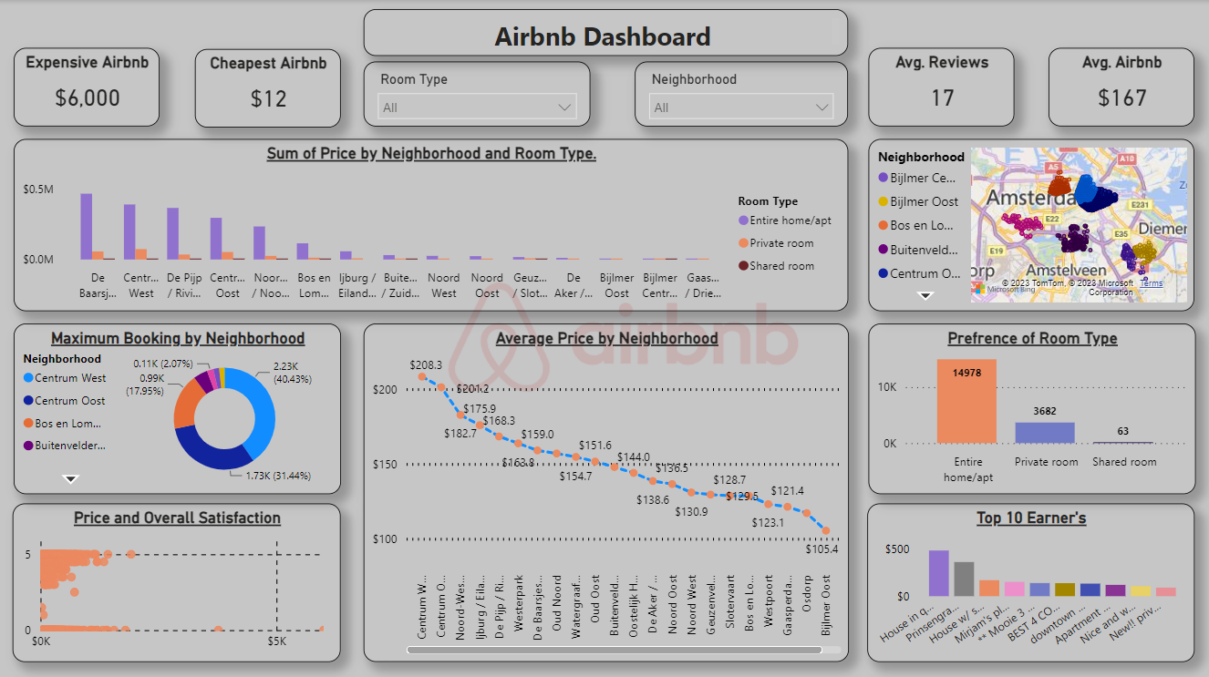

1. **Cards showing a different measures :**

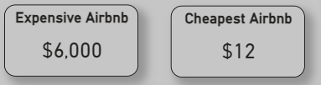

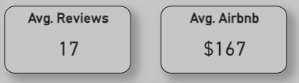

**Expensive Airbnb :** In a city or a particular location the most expensive Airbnb property rates.

**Cheapest Airbnb :** In a city or a particular location the cheapest price of Airbnb property.

**Avg. Reviews :** In a city or a particular Location the Airbnb Property has How much Avg. Reviews given by Customer.

**Avg. Airbnb :** In a city a particular Airbnb Property Location has a Booking.

1. **Slicers of Room Type and Location :**

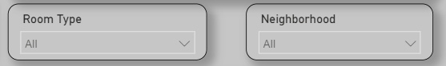

1. **Sum of Price with respect to Location And Room Type :**

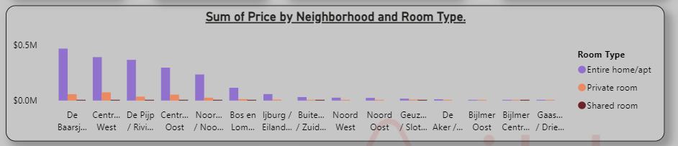

This visualization showing a insides, that the Sum of Price of the airbnb property as per the locations and the room type.

It has also a drill through visualization that only showing the price w.r.t. the neighborhood as a location.

1. **Showing Neighborhood Location on City Map :**

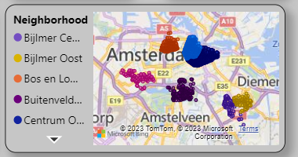

A dataset is having a coordinates of a locations as a latitude and longitude, so we can visualize the map on the dashboard.

1. **Maximum Booking by Neighborhood :**

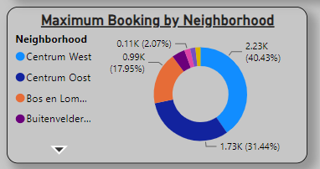

Here we can see the pie chart of top 10 booking Neighborhood by the count of Neighborhoods.

1. **Top 10 Earner’s :**

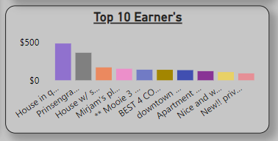

Top Earners means The Top Propertys of city having a maximum earnings as per the highest average price of bookings by the name of the property.

1. **Top 10 Booking’s by Name :**

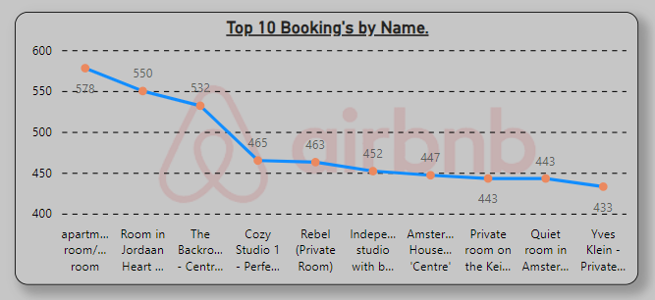

1. **Preference of Room Type :**

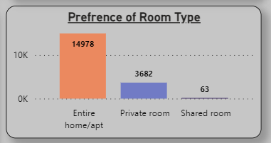

1. **Average Price by Neighborhood :**

